**InsightStream - NewsApp: Navigate the News**

**Overview**

The **News App** is a modern, responsive web application built using **ReactJS** that allows users to browse, search, and read the latest news articles from various sources. The app fetches real-time news data from a third-party API (e.g., [NewsAPI](https://newsapi.org/" \t "_blank)) and provides a seamless user experience with features like category filtering, search functionality, infinite scroll, and dark/light mode support.

This documentation provides a detailed explanation of the app's architecture, features, components, API integration, and deployment process.

**Team Details :**

**Team Lead :** KAMALESH S

Email id : [skamaleshsky@gmail.com](mailto:skamaleshsky@gmail.com)

Team Members :

1. LOKESH BABU V

Email id : [23munampulikesi@gmail.com](mailto:23munampulikesi@gmail.com)

1. KISHORE V

Email id : [kishorevenkatesan229@gmail.com](mailto:kishorevenkatesan229@gmail.com)

1. KARTHIKEYAN E

Email id : [karthikeyankarthik0802@gmail.com](mailto:karthikeyankarthik0802@gmail.com)

1. LOKESH B

Email id : [lokesh70822@gmail.com](mailto:lokesh70822@gmail.com)

**INTRODUCTION**

In the modern digital age, staying updated with the latest news is essential. With the vast amount of information available online, a News App provides a centralized platform for users to access curated news articles based on their preferences. By leveraging React.js, we can build a powerful, fast, and user-friendly news application that dynamically fetches and displays news articles from various sources.

**Core Features of the News App**

1. **Fetching Live News with APIs**
   * The app integrates with third-party news APIs such as NewsAPI, NY Times API, or Google News API to fetch real-time news articles.
   * API requests are handled using fetch() or Axios in combination with React’s useEffect() hook.
2. **Categorized News Sections**
   * Users can browse news by categories like Technology, Business, Sports, Politics, Health, and Entertainment.
   * Dynamic routing (via React Router) allows users to switch between different categories seamlessly.
3. **Search and Filtering Functionality**
   * A search bar allows users to find news articles based on keywords.
   * Filters can be applied to sort news by date, relevance, or source.
4. **Pagination and Infinite Scrolling**
   * The app implements pagination for structured browsing or infinite scrolling for a seamless experience.
   * News articles load dynamically as the user scrolls down, improving performance and engagement.
5. **Dark Mode and Responsive Design**
   * Users can switch between light and dark themes for better readability.
   * The app is fully responsive, ensuring smooth functionality across desktop, tablet, and mobile devices.
6. **User Authentication and Saved Articles (Optional Feature)**
   * Firebase Authentication or OAuth (Google, Facebook) can be integrated to enable user logins.
   * Users can save articles to read later, enhancing user engagement and retention.

**Features**

1. **Browse News by Category**:
   * Users can view news articles categorized by topics such as Business, Technology, Sports, Entertainment, Health, Science, etc.
   * Categories are displayed in a navigation bar for easy access.
2. **Search Functionality**:
   * Users can search for specific news articles by entering keywords in the search bar.
   * The app dynamically filters and displays relevant articles based on the search query.
3. **Responsive Design**:
   * The app is designed to work seamlessly across devices (desktop, tablet, and mobile).
   * A mobile-friendly navigation menu is provided for smaller screens.
4. **Infinite Scroll**:
   * News articles are loaded dynamically as the user scrolls down the page, improving performance and user experience.
5. **Detailed Article View**:
   * Users can click on a news article to view its full content, including the title, description, image, source, and publication date.
   * A "Read More" button redirects users to the original article on the source website.
6. **Dark/Light Mode**:
   * The app supports both dark and light themes, allowing users to switch between themes based on their preference.
7. **Error Handling**:
   * The app displays user-friendly error messages for scenarios like API failures, no search results, or network issues.

**Technologies Used**

* **ReactJS**: A JavaScript library for building user interfaces.
* **React Router**: For handling navigation and routing within the app.
* **Axios**: For making HTTP requests to the news API.
* **CSS Modules**: For styling components in a modular and scoped way.
* **React Hooks**: For managing state and side effects (e.g., useState, useEffect, useContext).
* **NewsAPI**: A third-party API for fetching real-time news data.
* **React Icons**: For adding icons (e.g., search, theme toggle).
* **Environment Variables**: For securely storing and accessing the API key.

**Installation**

To set up and run the News App locally, follow these steps:

1. **Clone the Repository**:

bash

Copy

git clone https://github.com/your-username/news-app.git

cd news-app

1. **Install Dependencies**:

bash

Copy

npm install

1. **Set Up API Key**:
   * Sign up for a free API key from [NewsAPI](https://newsapi.org/" \t "_blank).
   * Create a .env file in the root directory and add your API key:

Env

REACT\_APP\_NEWS\_API\_KEY=your\_api\_key\_here

1. **Run the App**:

bash

npm start

The app will be available at http://localhost:3000.

**Folder Structure**

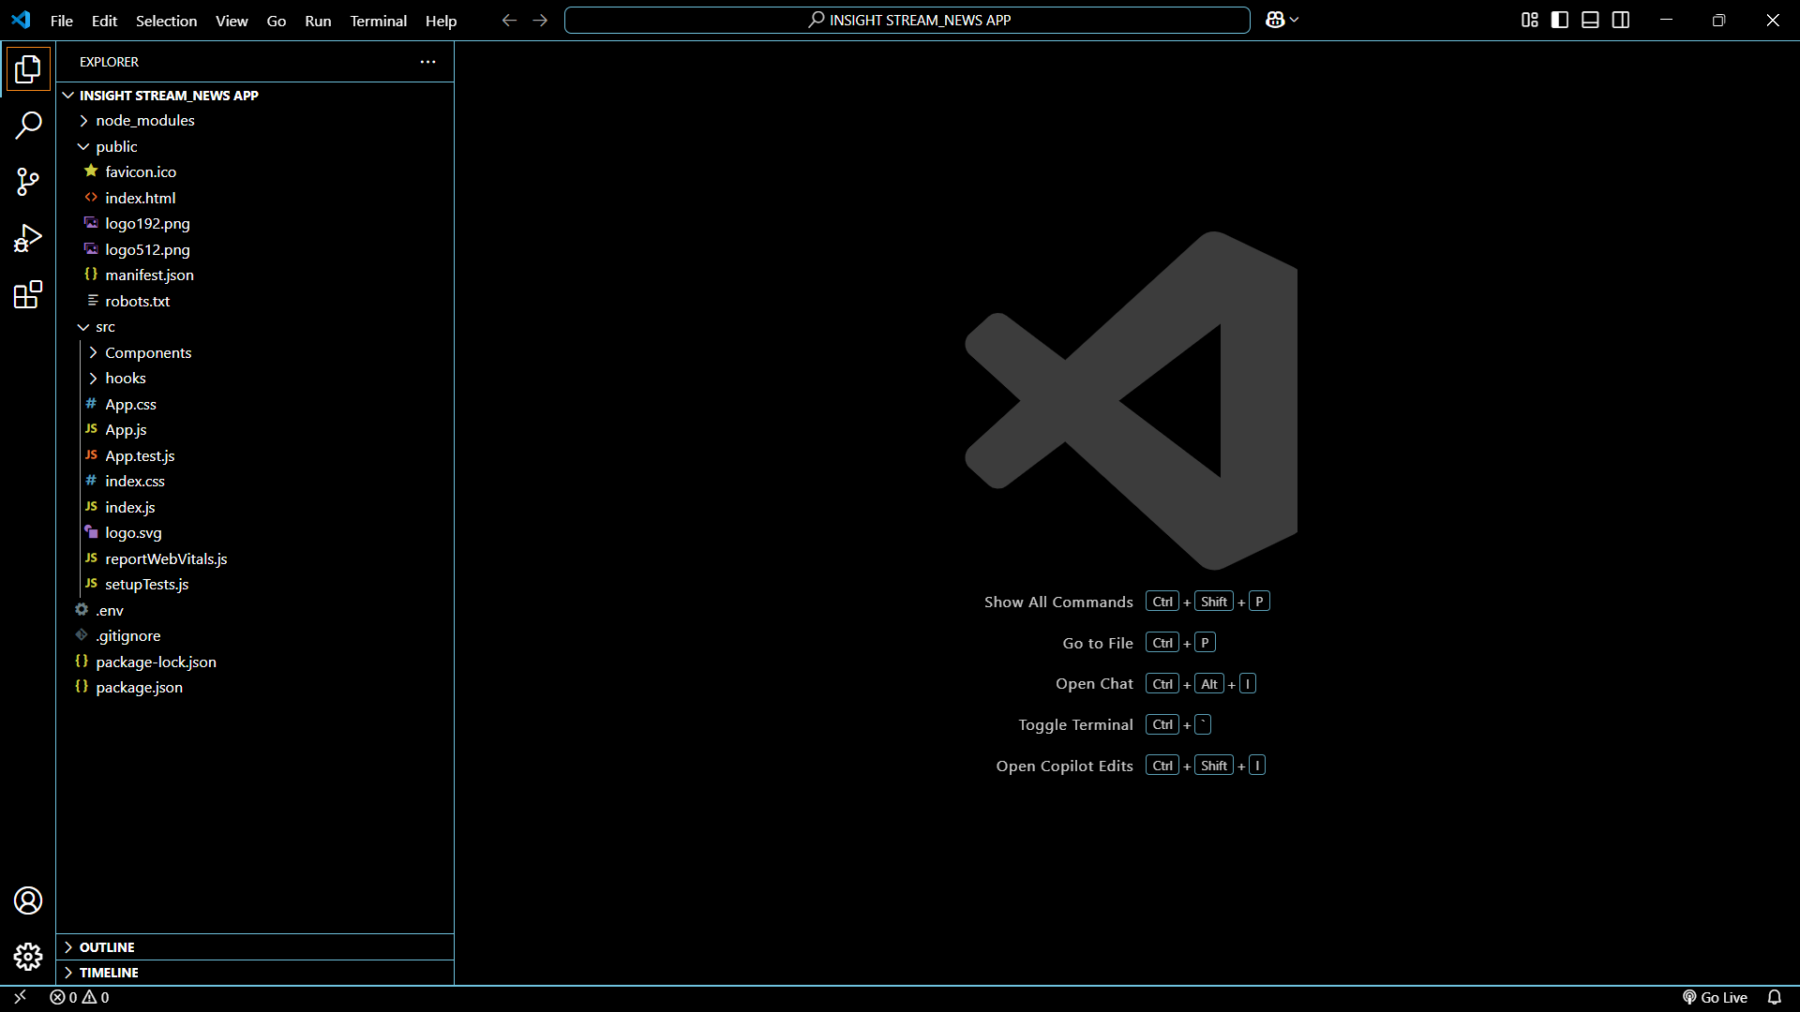

**Component Documentation**

**1. Header**

* Displays the app logo, navigation links, and theme toggle button.
* Props: None
* State: Manages the current theme (dark/light).

**2. NewsItem**

* Represents a single news article.
* Props:
  + title: Title of the article.
  + description: Short description of the article.
  + imageUrl: URL of the article's image.
  + url: Link to the full article.
  + publishedAt: Publication date of the article.
* State: None

**3. NewsList**

* Displays a list of news articles.
* Props:
  + articles: Array of news articles.
  + loading: Boolean to indicate if data is being fetched.
* State: Manages loading state for infinite scroll.

**4. SearchBar**

* Allows users to search for news articles.
* Props:
  + onSearch: Callback function to handle search queries.
* State: Manages the search input value.

**5. ThemeToggle**

* Toggles between dark and light themes.
* Props: None
* State: Manages the current theme.

**6. Loader**

* Displays a loading spinner while data is being fetched.
* Props: None
* State: None

**API Integration**

The app uses the **NewsAPI** to fetch news data. The API endpoints are accessed via the axios library.

**Example API Call:**

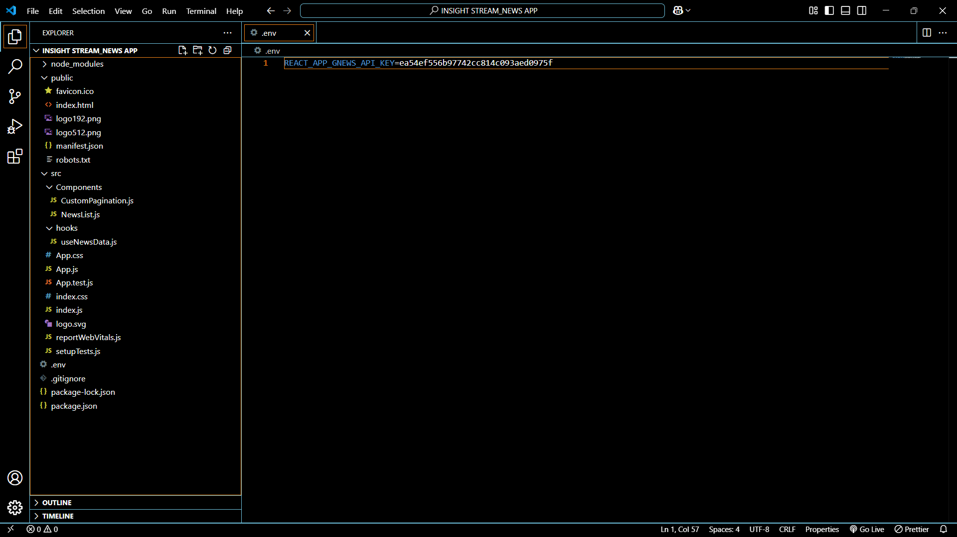

**Routing**

The app uses react-router-dom for navigation. Routes are defined in routes.js.

**Example Routes:**

Javascript

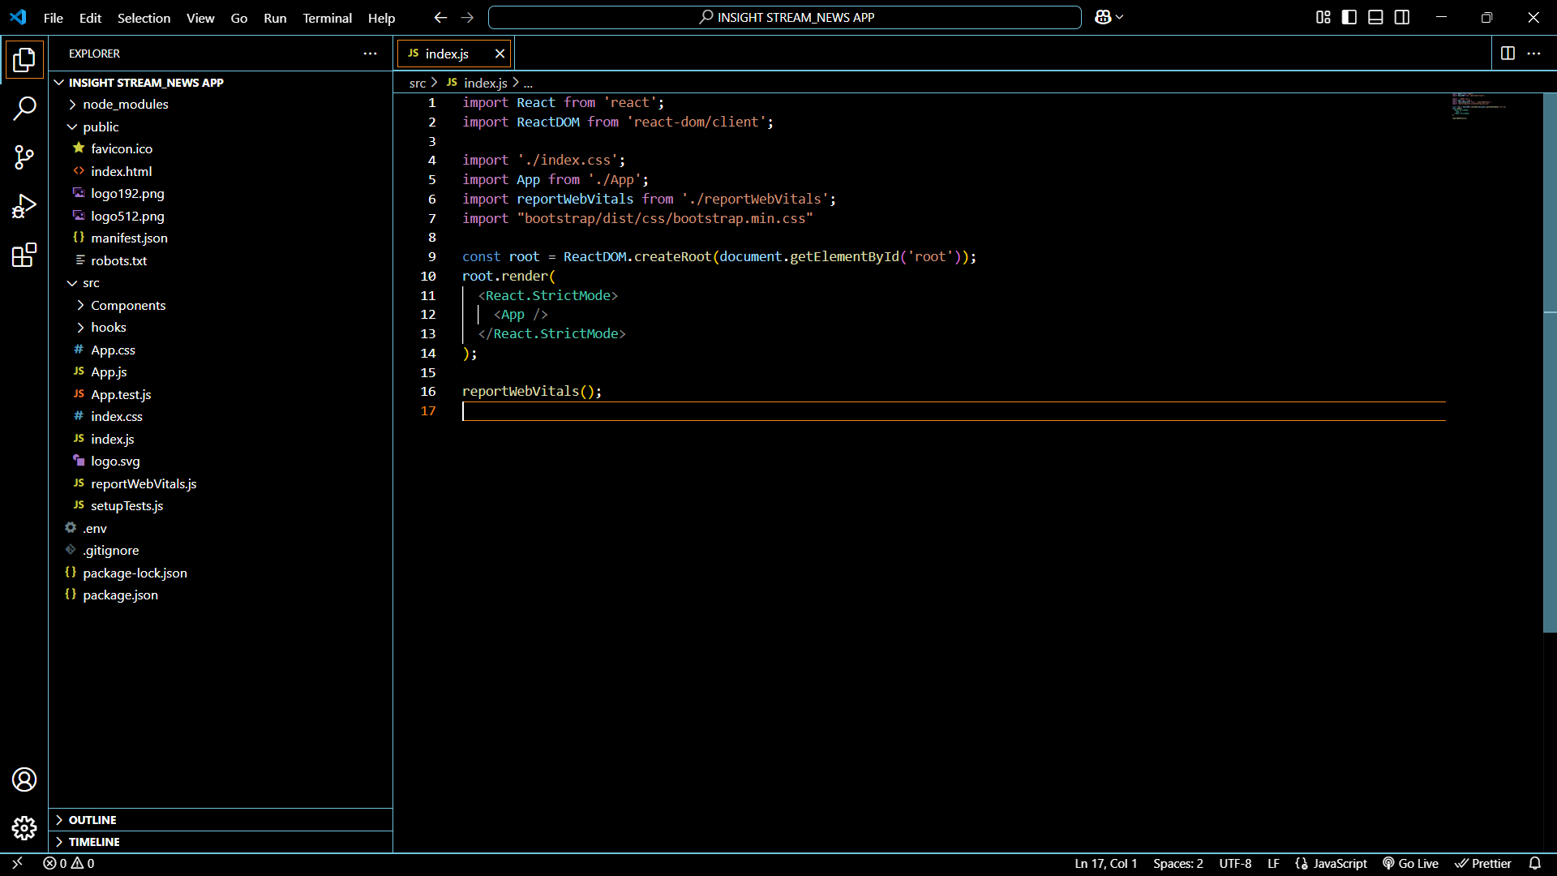

**State Management**

The app uses React's built-in state management tools:

* useState: For managing local component state (e.g., search input, loading state).
* useContext: For managing global state (e.g., theme).

**Example Theme Context:**

javascript

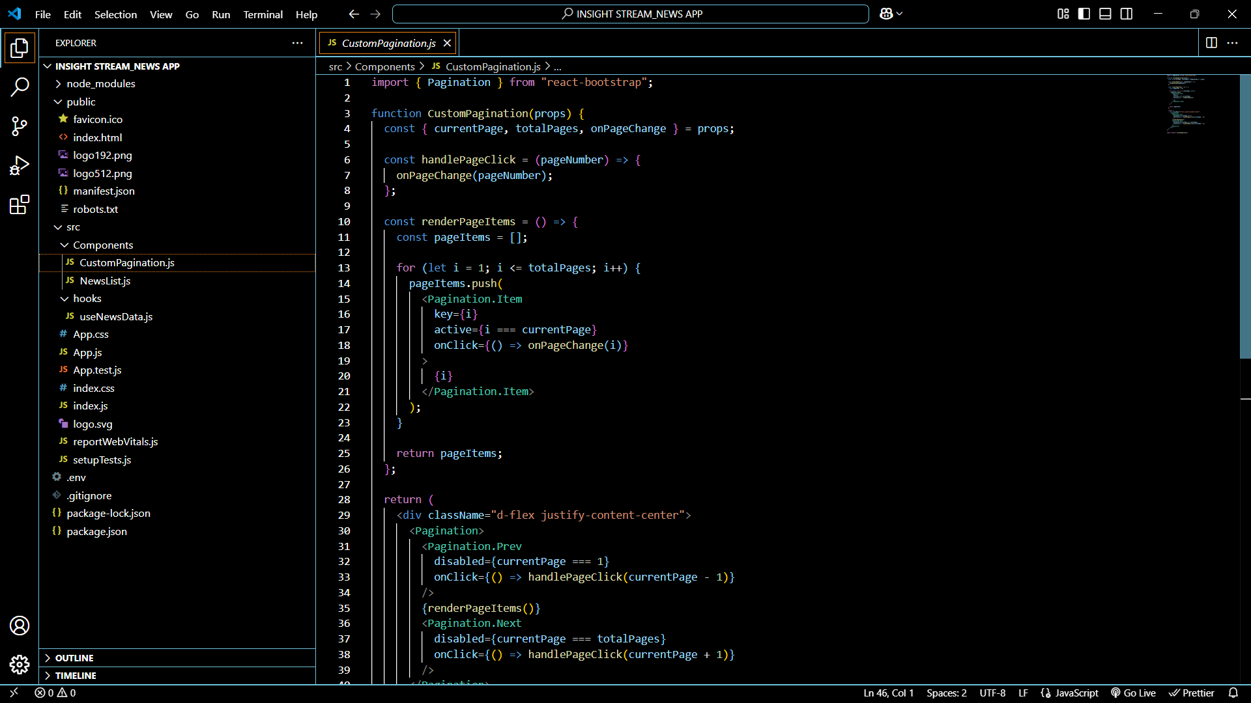

**Styling**

The app uses **CSS Modules** for component-specific styling and global styles for shared styles.

**Example Theme Styles:**

css

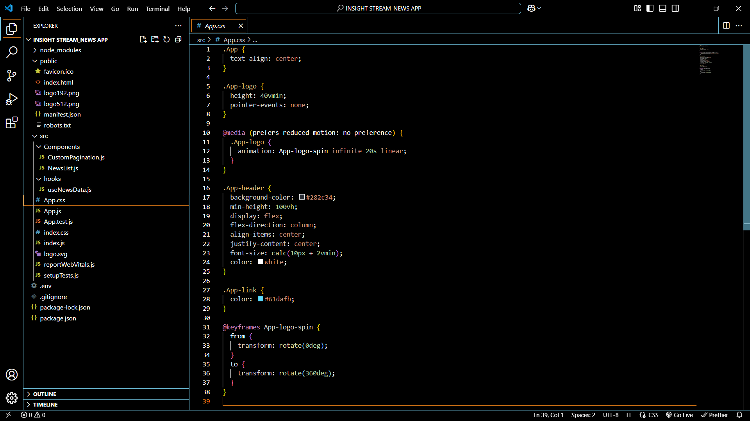

**Deployment**

To deploy the app, follow these steps:

1. Build the app:

bash

Copy

npm run build

1. Deploy the build folder to your preferred hosting platform (e.g., Netlify, Vercel, GitHub Pages).

**Contributing**

Contributions are welcome! Please follow these steps:

1. Fork the repository.
2. Create a new branch for your feature or bugfix.
3. Submit a pull request with a detailed description of your changes.

**License**

This project is licensed under the MIT License. See the [LICENSE](https://license/) file for details.

**SOURCE LINK** :

* GitHub: <https://github.com/Kamalesh-Sky/NEWS-APP_INSIGHT-STREAM>

**Demo Video :**

* <https://drive.google.com/file/d/1OM-uR-o6Qr7ljAYIh5SdZ-2DmI8r2Dc6/view?usp=drivesdk>